Seychelles Islands Foundation

ALDABRA ATOLL

RESEARCH OFFICER'S ANNUAL REPORT
JUNE 1999 – JULY 2000

This report summarizes scientific and conservation work at Aldabra during the period June 1999 to July 2000, and draws on information from the Research Officer’s Annual Report June 98-June 99. Reference is made to the Aldabra Management Plan Version 1 : 1998 (Beaver & Gerlach), as Operations Manual (OM) and Management Plan (MP).

- RESEARCH & MONITORING

  - Long-term monitoring

Carried out by Rangers and suitably trained volunteers under supervision of Senior Ranger, responsible to the Research Officer who sets the programme and assists. The monthly schedule is based around Appendix A, Turtle Monitoring at Aldabra 1997 Version (Mortimer), but has been expanded to include (particularly) bird monitoring. Monthly schedules are submitted to SIF Executive Director as part of RO’s bi-monthly report, and are reproduced here as Appendix 1. Schedules as devised at the beginning of a monthly cycle usually have to be amended in the light of subsequent events. Those in Appendix 1 are the final, corrected versions. Reading of raingauges, turtle track counts, tortoise transect counts and landbird point counts carried out routinely each month on Picard are not included on these schedules.

Record of activities is also made on Event Record Cards (Library Card Index) as OM 8.3.3, copied to Executive Director for 22/6/98 to 1/8/00.

Interruptions to schedules

The following monthly visits were missed or interrupted due to heavy seas, health and safety incidents or, in the first 2 weeks of December, unavailability of outboard oil:

Anse Malabar Middle Camp Gionnet Polymnie
June 99 June 99 (rail transect only missed) December 99 December 99
November 99 December 99 May 2000 May 2000
December 99

Cinq Cases Dune Jean-Louis Dune d’Messe
December 99 February 2000 February 2000

    - Weather recording

A refurbished Stephenson screen and recording equipment were provided by Seychelles Meteorological Department in December and the following values are now taken daily at 8am at the Warden’s house.

Wet and dry bulb temperatures.
Maximum and minimum temperatures
Rainfall
Wind direction and speed

The Meteorological Department also reactivated their automatic station, and wind speed/direction are taken from this.

A Barograph is sited in the Library and a Thermo/Hygrograph in the Stephenson screen, recording sheets replaced at 8am each Monday. Recording cards have been provided for the sunshine recorder, which are replaced daily.

All data is forwarded to the Met. Dept., with copies on Aldabra, and that for December 99 to July 00 is shown as Appendix 2.

By request of Mr. Solomon Prosper, all rainfall data 1994 to present, together with a map of Aldabra rain gauge locations, has been supplied to Met. Dept., with request for results of any analyses resulting from this or other Aldabra weather data.

1.1.2.1 Rainfall

12 rain gauges are sited around the atoll, emptied monthly, plus one at Picard Station which is emptied daily at 8am, as OM 6.2. Anse Var gauge is emptied twice weekly when necessary during wet periods due to its smaller capacity. Data stored on Library card index and computer and included in Research Officer’s bi-monthly reports to SIF Executive Director.

Raingauge data June 1999 to July 2000

1. Station 2. Anse Var 3. Bassin Lebines 4. Polymnie 5. Esprit
Date | Rain mm |  | Date | Rain mm |  | Date | Rain mm |  | Date | Rain mm |  | Date | Rain mm
1/7/99 | 27.7 |  | 8/7/99 | 24.9 |  | 10/7/99 | 29.0 |  | 10/7/99 | 30.0 |  | 14/7/99 | 35.0
1/8/99 | 28.7 |  | 9/8/99 | 22.7 |  | 20/8/99 | 17.0 |  | 9/8/99 | 25.8 |  | 16/8/99 | 5.0
1/9/99 | 2.9 |  | 4/9/99 | 2.3 |  | 1/10/99 | 15.0 |  | 9/9/99 | 3.0 |  | 16/9/99 | 1.0
1/10/99 | 9.1 |  | 16/10/99 | 6.7 |  | 3/11/99 | 8.0 |  | 11/10/99 | 8.0 |  | 14/10/99 | 17.0
1/11/99 | 7.4 |  | 15/11/99 | 7.2 |  | 3/12/99 | 19.0 |  | 8/11/99 | 9.0 |  | 12/11/99 | 5.0
1/12/99 | 13.1 |  | 17/12/99 | 41.6 |  | 31/12/99 | 121.0 |  | 16/12/99 | 60.0 |  | 15/12/99 | 49.0
1/1/00 | 131.6 |  | 26/12/99 | 92.8 |  | 28/1/00 | 108.0 |  | 8/1/00 | 107.0 |  | 12/1/00 | 83.0
1/2/00 | 50.6 |  | 14/1/00 | 6.5 |  | 25/2/00 | 10.0 |  | 2/2/00 | 22.0 |  | 17/2/00 | 44.0
1/3/00 | 13.4 |  | 17/2/00 | 29.8 |  | 26/3/00 | 122.0 |  | 6/3/00 | 70.0 |  | 8/3/00 | 42.0
1/4/00 | 122.0 |  | 17/3/00 | 22.9 |  | 27/4/00 | 30.0 |  | 4/4/00 | 89.0 |  | 18/4/00 | 48.0
1/5/00 | 34.4 |  | 23/3/00 | 82.0 |  | 24/5/00 | 25.0 |  | 2/6/00 | 34.0 |  | 21/5/00 | 52.0
1/6/00 | 20.0 |  | 28/3/00 | 16.8 |  | 15/6/00 | 17.0 |  | 3/7/00 | 39.2 |  | 13/6/00 | 2.0
1/7/00 | 20.4 |  | 15/4/00 | Nil |  | 15/7/00 | 85.0 |  | 31/7/00 | 27.0 |  | 13/7/00 | 65.0
 |  |  | 15/5/00 | 28.7
 |  |  | 15/6/00 | 29.1
 |  |  | 17/7/00 | 73.0
Total | 481.3 |  | Total | 487 |  | Total | 606 |  | Total | 524 |  | Total | 448

6. Gionnet 7. Middle Camp 8. Anse Malabar 9. Cinq Cases 10. CC Groves
Date | Rain mm |  | Date | Rain mm |  | Date | Rain mm |  | Date | Rain mm |  | Date | Rain mm
10/7/99 | 28.0 |  | 28/6/99 | 35.0 |  |  |  |  | 29/6/99 | 59.0* |  | 29/6/99 | 63.0**
9/8/99 | 28.0 |  | 29/7/99 | 39.0 |  | 4/8/99 | 76.0 |  | 2/8/99 | 30.0 |  | 1/8/99 | 50.0
9/9/99 | 2.0 |  | 6/9/99 | Nil |  | 6/9/99 | 6.0 |  | 29/8/99 | 6.0 |  | 29/8/99 | 2.0
11/10/99 | 8.0 |  | 8/10/99 | 11.0 |  | 7/10/99 | 10.0 |  | 28/9/99 | 11.0 |  | 28/9/99 | 11.0
8/11/99 | 8.0 |  | 3/11/99 | 8.0 |  | 28/12/99 | 118.0 |  | 28/10/99 | Nil |  | 29/10/99 | Nil
17/12/99 | 50.0 |  | 28/12/99 | 118.0 |  | 7/2/00 | 43.0 |  | 25/11/99 | 20.0 |  | 26/11/99 | 20.0
8/1/00 | 76.0 |  | 7/2/00 | 31.0 |  | 28/2/00 | 26.0 |  | 21/1/00 | 143.0 |  | 22/1/00 | 135.0
2/2/00 | 35.0 |  | 29/2/00 | 28.0 |  | 27/3/00 | 110.0 |  | 21/2/00 | 72.0 |  | 21/2/00 | 56.0
26/2/00 | 10.0 |  | 26/3/00 | 101.0 |  | 27/4/00 | 8.0 |  | 21/3/00 | 70.0 |  | 23/3/00 | 70.0
14/3/00 | 60.0 |  | 27/4/00 | 7.0 |  | 22/5/00 | 12.0 |  | 19/4/00 | 102.0 |  | 20/4/00 | 54.0
4/4/00 | 41.0 |  | 22/5/00 | 14.0 |  | 27/6/00 | 75.0 |  | 18/5/00 | 9.0 |  | 18/5/00 | 4.0
7/6/00 | 28.0 |  | 27/6/00 | 61.0 |  | 26/7/00 | 15.0 |  | 29/6/00 | 83.0 |  | 30/6/00 | 73.0
3/7/00 | 70.0 |  | 26/7/00 | 9.0 |  |  |  |  | 1/8/00 | 44.0 |  | 2/8/00 | 40.0
31/7/00 | 38.0
Total | 482 |  | Total | 462 |  | Total | 499 |  | * Total | (649) 629 |  | ** Total | (578) 553

11. Dune Jean-Louis 12. Dune d’Messe 13. Anse Mais
Date | Rain mm |  | Date | Rain mm |  | Date | Rain mm
12/6/99 | 30.0 |  | 12/6/99 | 18.0 |  | 16/6/99 | 19.0
13/7/99 | 34.0 |  | 14/7/99 | 40.0 |  | 22/7/99 | 35.0
12/8/99 | 3.0 |  | 13/8/99 | 3.0 |  | 25/8/99 | 10.0
14/9/99 | 6.0 |  | 15/9/99 | 1.0 |  | 24/9/99 | 2.0
12/10/99 | 9.0 |  | 13/10/99 | 10.0 |  | 21/10/99 | 8.0
10/11/99 | 11.0 |  | 11/11/99 | 13.0 |  | 22/11/99 | 21.0
13/12/99 | 98.0 |  | 14/12/99 | 107.0 |  | 20/12/99 | 57.0
10/1/00 | 87.0 |  | 11/1/00 | 53.0 |  | 18/1/00 | 93.0
6/3/00 | 18.0 |  | 6/3/00 | 55.0 |  | 15/2/00 | 48.0
6/4/00 | 64.0 |  | 5/4/00 | 70.0 |  | 16/3/00 | 41.0
3/5/00 | 17.0 |  | 3/5/00 | 20.0 |  | 13/4/00 | 90.0
31/5/00 | 7.0 |  | 1/6/00 | 17.0 |  | 13/5/00 | 32.0
4/7/00 | 55.0 |  | 5/7/00 | 71.0 |  | 9/6/00 | 22.0
2/8/00 | 21.0 |  | 3/8/00 | 33.0 |  | 11/7/00 | 65.0
Total | 460 |  | Total | 511 |  | Total | 543

* Cinq Cases previous recording was 28/4/99. Figure of 59mm includes an estimated 20mm for the month of May 99 Cinq Cases total is adjusted downwards by 20mm to account for this.

** CC Groves previous recording was 29/4/99. Figure of 63mm includes an estimated 25mm for the month of May 99. CC Groves total is adjusted downwards by 25mm to account for this.

Location of rain gauges and distribution of rainfall June 99 to July 00 is shown in Appendix 10.

Annual rainfall at Station 1994-1999

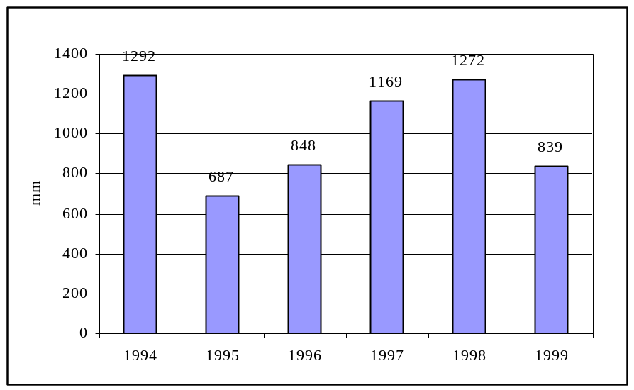

Monthly rainfall at Station January 1994 to December 1999

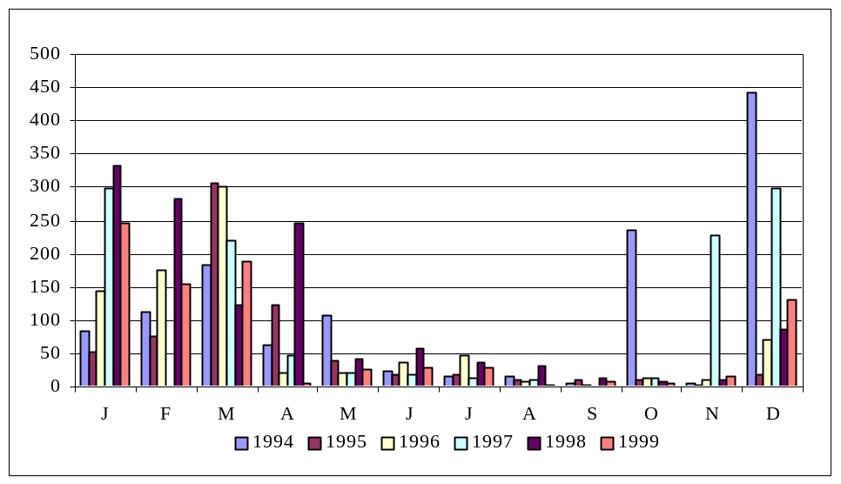

 | Jan | Feb | Mar | Apr | May | June | July | Aug | Sept | Oct | Nov | Dec | Total
1994 | 84.4 | 112.0 | 183.0 | 63.3 | 107.8 | 24.8 | 14.9 | 14.5 | 4.7 | 235.4 | 5.3 | 442.3 | 1292.4
1995 | 53.0 | 76.6 | 306.7 | 122.4 | 38.1 | 18.3 | 19.6 | 10.4 | 10.8 | 10.4 | 2.0 | 19.0 | 687.3
1996 | 145.0 | 175.6 | 301.6 | 19.7 | 19.9 | 36.8 | 46.5 | 6.6 | 3.6 | 12.4 | 10.1 | 70.0 | 847.8
1997 | 298.2 | 0.0 | 220.3 | 48.0 | 21.4 | 19.4 | 12.0 | 9.2 | 0.8 | 12.6 | 227.8 | 299.0 | 1168.7
1998 | 332.5 | 282.6 | 124.3 | 246.6 | 41.2 | 58.3 | 37.4 | 32.6 | 12.6 | 8.1 | 10.2 | 85.1 | 1271.5
1999 | 246.9 | 153.7 | 187.8 | 4.9 | 24.9 | 27.7 | 28.7 | 2.9 | 9.1 | 4.80 | 15.7 | 131.6 | 838.7
Mean | 193.3 | 133.4 | 220.6 | 84.2 | 42.2 | 30.9 | 26.5 | 12.7 | 6.9 | 47.7 | 44.8 | 174.5 | 1017.7
Mean 1949-76 | 162 | 140 | 171 | 169 | 43 | 36 | 32 | 21 | 9 | 8 | 46 | 92 | 966

Reference: ‘Long-term climatic change’ in ‘The terrestrial ecology of Aldabra’. Stoddart ed. 1979.

1.1.3 Green Turtle Chelonia mydas

The turtle monitoring and research programme is directed by Dr. Jeanne Mortimer, who provided re-designed computer database and field recording sheets in February 2000. Original data sheets are sent to her on Mahe, with photocopies and computer files held on Aldabra.

Track counts

Carried out as OM 6.4, once monthly at the majority of beaches and at least 4 times monthly at Settlement Beach (No. 47) and West Grande Terre (Nos. 1-22).

Mean track counts all beaches 11/6/99 to 30/6/00

Beach No. | No. counts | No. VF tracks | Tracks per count (98/9) | Beach No. | No. counts | No. VF tracks | Tracks per count (98/9)
1 | 44 | 0 | 0.00 (0.03) | 26 | 20 | 4 | 0.20 (0.90)
2 | 46 | 17 | 0.37 (0.73) | 27 | 10 | 0 | 0.00 (0.14)
3 | 47 | 14 | 0.23 (1.42) | 28 | 10 | 5 | 0.50 (0.64)
4 | 47 | 11 | 0.30 (1.29) | 29 | 11 | 2 | 0.18 (0.42)
5 | 47 | 23 | 0.49 (2.20) | 30 | 11 | 3 | 0.27 (1.92)
6 | 47 | 15 | 0.32 (0.69) | 31 | 13 | 4 | 0.30 (0.33)
7 | 47 | 42 | 0.89 (1.76) | 32 | 13 | 22 | 1.69 (3.43)
8 | 47 | 42 | 0.89 (4.42) | 33 | 13 | 11 | 0.84 (1.50)
9 | 47 | 33 | 0.70 (3.56) | 34 | 13 | 18 | 1.38 (2.25)
10 | 47 | 0 | 0.00 (0.07) | 35 | 13 | 5 | 0.38 (0.50)
11 | 47 | 1 | 0.02 (0.42) | 36 | 13 | 3 | 0.23 (0.92)
12 | 47 | 2 | 0.04 (0.40) | 37 | 12 | 0 | 0.00 (0)
13 | 47 | 0 | 0.00 (0.11) | 38 | 14 | 0 | 0.00 (0)
14 | 47 | 0 | 0.00 (0.02) | 38.5 | 14 | 0 | 0.00 (0.64)
15 | 55 | 78 | 1.41 (5.11) | 39 | 11 | 0 | 0.00 (0.11)
15.5 | 55 | 7 | 0.13 (0.31) | 40 | 1 | 4 | 4.00 (0.00)
16 | 55 | 18 | 0.33 (1.96) | 41 | 12 | 4 | 0.33 (1.40)
17 | 55 | 79 | 1.44 (5.76) | 42 | 16 | 26 | 1.62 (3.70)
17.5 | 55 | 2 | 0.34 (0.11) | 43 | 16 | 15 | 0.94 (1.30)
18 | 55 | 52 | 0.94 (2.13) | 43.5 | 0 | 0 | 0.00 (0.00)
19 | 55 | 136 | 2.47 (6.29) | 44 | 4 | 6 | 1.50 (6.00)
20 | 55 | 46 | 0.84 (3.75) | 45 | 6 | 0 | 0.00 (1.00)
21 | 55 | 54 | 0.98 (2.25) | 46 | 1 | 1 | 1.00 (0.00)
22 | Obsolete |  | (0.00) | 47 zone 1 | 95 | 7 | 0.07 (0.16)
23 | 2 | 2 | 1.00 (0.42) | 47 zone 2 | 95 | 73 | 0.77 (1.61)
24 | 13 | 0 | 0.00 (0.00) | 47 zone 3 | 95 | 28 | 0.29 (1.28)
25 | 13 | 0 | 0.00 (0.07) | 47 zone 4 | 95 | 164 | 1.73 (3.56)

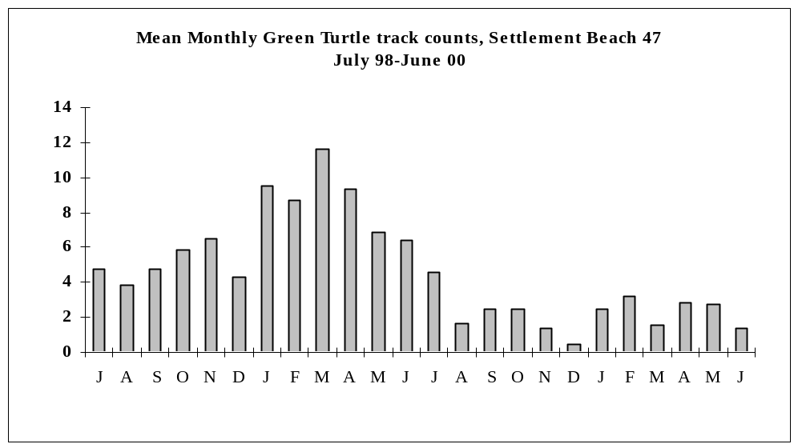

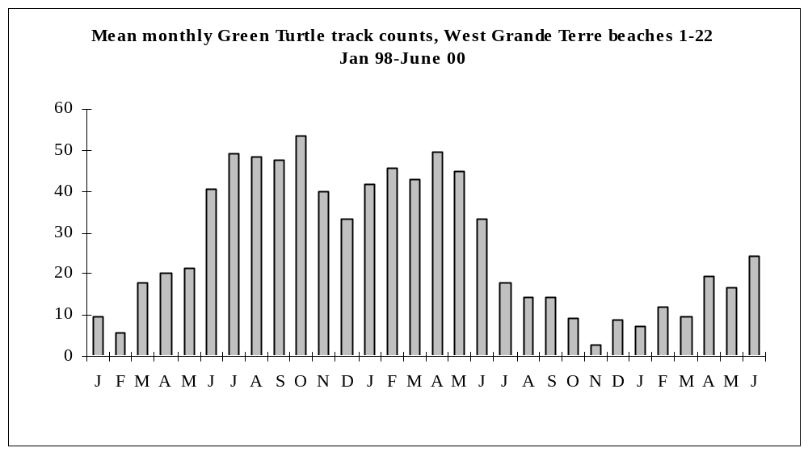

Photographs of beaches 1 to 22 were taken by boat in February 2000, to be repeated in August/September in order to register any seasonal change.

Location of Turtle beaches is shown on Appendix 11.

Tagging

Carried out as OM 6.4, but applying one tag only (rather than one to each front flipper) from 27.7.99.

A total of 99 turtles were encountered during the period 11/6/99 to 31/7/00, of which 85 were given tags.
14 were already tagged, one of them probably by Jeanne Mortimer at Aldabra in June 1981, although the tag, which was replaced and returned to Dr. Mortimer, is worn and difficult to read. These figures compare with over 300 encountered during the corresponding period 1998/9. 2 of the 83 turtles tagged in 99/00 were males stranded during mating. In addition 7 juveniles were tagged.

Problems in tag application mentioned in the 98/99 report were due to the occasional faulty tag, rather than the applicator. Dr. Mortimer found that workers elsewhere were having the same problem. A pair of long-nosed pliers is now carried by Rangers to ensure the tag fits properly into the applicator.

No details of recoveries of turtles away from Aldabra were received during the period June 99 to June 00.

1.1.4 Hawksbill Turtle Eretmochelys imbricata

Data stored as for Green Turtle, original data sheets to Jeanne Mortimer.

Track counts

Carried out 1/9/99 to 31/3/00, as OM 6.4.

A total of 10 very fresh sets of tracks (less than 24hrs old) was counted in the period (8 in the corresponding period 1998/9).

Polymnie Beaches I to VI have shown no activity and are not suitable for nesting. They were suspended from the monthly survey January 2000 as a time-saving measure but will be monitored for signs of improvement.

Nesting Hawksbills

Nesting females were found at Ile Esprit on 12/1/00 and at Anse Var on 16/10/99. Both were tagged, measured and the latter tissue-sampled.

Juvenile growth study

52 juveniles were caught between 11/6/99 and 31/7/00, either at Passe Houareau at low tide or off Ile Moustiques using the ‘rodeo’ method, 15 already tagged. All were carefully measured, weighed and tagged if necessary, as Appendix 1, Turtle Monitoring at Aldabra 1997 Version (Mortimer).

Method of capture at Passe Houareau involves 2-4 people searching at low-tide on foot for c2 hours each month and catching young turtles by hand. This will inevitably have a cumulative impact on coral growth on the reef flats west and southwest of the channel.

DNA sampling

Tissue samples were taken from the hind flipper of 43 juvenile Hawksbills and sent to Dr. Mortimer.

SIF Chairman donated one disposable scalpel for taking samples, and the request for a further supply is repeated here.

1.1.5 Giant Tortoise Dipsochelys dussumieri

Data maintained on computer, original data sheets in Library. Disc copy of computer data sent to SIF every 4 months.

Transect counts

Carried out as OM 6.3, although generally by 1 or 2 workers rather than the 3 recommended. Each of 12 transects recorded monthly, with the exceptions noted at 1.1

Number of tortoises per transect
Transects | June 99 | July | Aug | Sept | Oct | Nov | Dec | Jan-00 | Feb | Mar | Apr | May | June | July
CC Coco | 41 | 29 | 21 | 20 | 33 | 14 | X | 80 | 87 | 109 | 42 | 60 | 33 | 25
CC Southern | 13 | 21 | 20 | 22 | 15 | 41 | X | 28 | 47 | 94 | 12 | 39 | 39 | 31
CC Groves | 17 | 20 | 8 | 17 | 21 | 25 | X | 30 | 12 | 19 | 19 | 10 | 26 | 18
DJL | 8 | 18 | 13 | 9 | 12 | 12 | 16 | 12 | x | 24 | 15 | 12 | 21 | 16
DDM Coastal | 11 | 31 | 19 | 9 | 16 | 67 | 92 | 92 | x | 113 | 74 | 36 | 21 | 35
DDM Lagoon | 22 | 9 | 19 | 13 | 34 | 11 | 12 | 16 | x | 8 | 12 | 28 | 37 | 17
MC Casuarina | 3 | 4 | x | 1 | 9 | 14 | 14 | 10 | 4 | 11 | 8 | 6 | 12 | 1
MC Inland | X | 8 | x | 18 | 7 | 11 | 26 | 15 | 33 | 45 | 29 | 11 | 17 | 25
Anse Malabar | X | X | 23 | 39 | 21 | x | 40 | 28 | 39 | 52 | 21 | 13 | 16 | 38
Picard Coastal | 12 | 26 | 17 | 39 | 3 | 37 | 97 | 24 | 49 | 30 | 38 | 13 | 1 | 60
Picard Backpath | 16 | 23 | 27 | 23 | 10 | 12 | 12 | 18 | 29 | 30 | 44 | 68 | 18 | 25
Anse Var | 8 | 10 | 4 | 6 | 0 | 5 | 2 | 15 | 10 | 12 | 9 | 2 | 9 | 2
A female was seen to lay 14 eggs at Anse Malabar transect on 27/7/00.

Opportunistic measurements

Some measurements of carapace length and width over the curve were made of animals carrying discs. Data entered onto Library card index. See also 1.2.6

1.1.6 Coccid Icerya seychellarum

Data stored on Aldabra computer, copied to SIF. Original data sheets stored at Aldabra.

Transect monitoring

The transects at La Gigi (Avicennia marina) and Anse Var (Euphorbia pyrifolia), both on Picard, at Gionnet and Middle Camp (both Sideroxylon inerme) on Malabar, and at Cinq Cases (Ficus lutea and Avicennia marina) on Grande Terre were recorded in the dry season (August 1999) and the wet season (January/February 2000) as OM 6.5.
Fairly heavy infestation noted on Cinq Cases beach crest Guettarda speciosa in October. Hermit Crab, probably Coenobite perlatus, observed eating coccids in foliage 4ft from the ground. This tree species (Bwa Kasan) appears to suffer heavier infestation than any other, but is not represented on the transects.

Report on monitoring and status of the coccid Icerya seychellarum on Aldabra 1980-1999

This report by volunteers Sharon Johnson and Robert Threadgold was submitted to SIF Executive Director in April 1999. Its main conclusions and recommendations, which include recruitment of new trees and establishment of a further transect, are listed in the 1998-99 Research Officer’s Report, with a request that the scientific sub-committee confirm or amend these following study of the report.

This request is repeated here.

    - White-throated Rail Dryolimnas cuvieri

Transect counts

Monthly recording of established transects at East Malabar (Middle Camp coccid transect), Anse Malabar (hut and inland rail transect), Gionnet (coccid transect) and Polymnie (hut and loop rail transect).

Method:

After 4pm, tape of Rail calls played (or whisted imitation more usually – tape players needed) every 100m at marked points for 15 seconds, listen for 30 seconds and repeat. Note all Rails heard or seen including those between count points and assign them to 50m sections and one side of the transect or the other, to avoid duplicating registrations, arriving at a total number of individuals noted and making other observations of rings, chicks, juveniles or behaviour, as required.
Two workers ideally required.

This method is suited to those transects (Gionnet, Polymnie) where visits usually have to be made on a single high tide and time is limited.

Numbers of Rails since recording began in January 1999 (length of transect in brackets):

Anse Malabar (1000m) Middle Camp (700m) Gionnet (400m) Polymnie (900m)
Date | No. birds |  | Date | No. birds |  | Date | No. birds |  | Date | No. birds
25/01/99 | 34 |  | 25/01/99 | 20 |  | January | x |  | January | x
25/02/99 | 48 |  | 25/02/99 | 22 |  | February | x |  | February | x
26/03/99 | 18 |  | 26/03/99 | 20 |  | 15/03/99 | 10 |  | 15/03/99 | 6
26/04/99 | 18 |  | 26/04/99 | 18 |  | 14/04/99 | 14 |  | 14/04/99 | 3
26/05/99 | 12 |  | 26/05/99 | 19 |  | 12/05/99 | 12 |  | 12/05/99 | 13
June | x |  | June | x |  | 14/06/99 | 15 |  | 14/06/99 | 7
04/08/99 | 15 |  | 31/7/99 | 9 |  | 10/07/99 | 11 |  | 14/07/99 | 4
06/09/99 | 13 |  | 07/09/99 | 18 |  | 09/08/99 | 15 |  | 09/08/99 | 5
07/10/99 | 9 |  | 07/10/99 | 18 |  | 09/09/99 | 3 |  | 09/09/99 | 4
November | x |  | 03/11/99 | 19 |  | 11/10/99 | 2 |  | 11/10/99 | 2
December | x |  | December | X |  | 08/11/99 | 5 |  | 08/11/99 | 10
05/01/00 | 14 |  | 06/01/00 | 16 |  | December | x |  | December | x
07/02/00 | 23 |  | 07/02/00 | 14 |  | 08/01/00 | 13 |  | 08/01/00 | 6
28/02/00 | 23 |  | 29/02/00 | 11 |  | 02/02/00 | 7 |  | 02/02/00 | 4
26/03/00 | 19 |  | 26/03/00 | 16 |  | 14/03/00 | 7 |  | 06/03/00 | 5
26/4/00 | 10 |  | 27/4/00 | 4 |  | 4/4/00 | 9 |  | 4/4/00 | 6
22/5/00 | 7 |  | 22/5/00 | 3 |  | May | x |  | May | x
27/6/00 | 14 |  | 27/6/00 | 12 |  | 7/6/00 | 3 |  | 2/6/00 | 7
26/7/00 | 8 |  | 27/7/00 | 10 |  | 3/7/00 | 9 |  | 8/7/00 | 2
 |  |  |  |  |  | 31/7/00 | 4 |  | 31/7/00 | 0

The two very large counts at Anse Malabar January and February 99 may have been due to the presence of juveniles and to inexperience with the counting method.

Adults were removed from the Middle Camp and Gionnet transects for translocation to Picard. 6 were taken from the former on 31/11/00, and 6 from the latter on 19-21/10/99. All were given metal and numbered yellow plastic rings.

Birds at Middle Camp, Gionnet and Polymnie have been ringed with metal and white plastic, numbered rings (blue plastic for juveniles) which will assist future monitoring and population estimates (see Appendix 3).

As the Picard population increases, transects can be recorded on the Backpath, the trail to Bassin Lebines, and the new trails at Anse Var and Bassin Caret.

See also 1.2.2.6

1997 Rail data

The missing data described in the previous report has been obtained from Roselle Chapman and copied to Ross Wanless along with subsequent data along with all subsequent data for assessment of population and trends at University of Capetown.

    - Vegetation monitoring

No vegetation monitoring was carried out during the period.

    - Subsistence fishing

Recording as OM 6.8, data on file and computer. Copies of monthly catch details are submitted to SIF in Research Officer’s bi-monthly report and to Seychelles Fishing Authority. Subsistence fishing for Station residents only is permitted (MP 3.3.2).

There are on average two 4 hour trips per month with 4 people fishing.

Total fish catch by species June 1999 to May 2000 (inclusive)

June to May allows direct comparison with the 1998/9 RO Report figures.

Family | Species | Number caught | Total weight - kg | Mean weight - kg | % of total catch by weight
Trevallies | Caranx ignobilis | 10 | 44.60 | 4.46
 | Caranx melampygus | 2 | 8.20 | 4.10 | 0.6%
 | Elagatis bipinnulata | 3 | 5.10 | 1.70 | 0.4%
 | Gnathanodon speciosus | 1 | 5.30 | 5.30 | 0.4%
Sweetlips | Plectorhinchus sp. | 1 | 1.70 | 1.70 | 0.1%
Wrasses | Bodianus bilunulatus | 1 | 0.70 | 0.70 | 0.1%
Emperors | Lethrinus borbonicus | 2 | 1.05 | 0.53 | 0.1%
 | Lethrinus microdon | 3 | 13.10 | 4.37 | 0.9%
 | Lethrinus nebulosus | 110 | 314.60 | 2.86 | 22.6%
 | Lethrinus rubrioperculatus | 20 | 19.70 | 0.99 | 1.4%
Snappers | Aprion virescens | 5 | 14.70 | 2.94 | 1.1%
 | Lutjanus bohar | 121 | 208.80 | 1.73 | 15.0%
 | Lutjanus gibbus | 10 | 11.30 | 1.13 | 0.8%
 | Lutjanus rivulatus | 1 | 2.70 | 2.70 | 0.2%

Family | Species | Number caught | Total weight - kg | Mean weight - kg | % of total catch by weight
Tunafishes | Acanthocybium solandri | 4 | 55.60 | 13.90 | 4.0%
 | Gymnosarda unicolor | 3 | 19.90 | 6.63 | 1.4%
 | Thunnus albacares | 8 | 69.30 | 8.66 | 5.0%
Groupers | Cephalopholis miniata | 20 | 10.30 | 0.52 | 0.7%
 | Cephalopholis sonnerati | 3 | 6.90 | 2.30 | 0.5%
 | Epinephelus fasciatus | 4 | 1.30 | 0.33 | 0.1%
 | Epinephelus fuscoguttatus | 1 | 5.50 | 5.50 | 0.4%
 | Epinephelus multinotatus | 86 | 201.80 | 2.35 | 14.5%
 | Epinephelus macrospilos | 6 | 7.90 | 1.32 | 0.6%
 | Epinephelus polyphekadion | 30 | 84.60 | 2.82 | 6.1%
 | Epinephelus tukula | 4 | 42.30 | 10.58 | 3.0%
 | Plectropomus laevis | 1 | 5.10 | 5.10 | 0.4%
 | Plectropomus punctatus | 5 | 30.70 | 6.14 | 2.2%
 | Variola louti | 91 | 164.60 | 1.81 | 11.8%
Barracudas | Sphyraena barracuda | 3 | 17.30 | 5.77 | 1.2%
Triggerfishes |  | 10 | 18.40 | 1.84 | 1.3%
 | Sufflamen fraenatus
 | Balistoides viridescens
 | Pseudobalistes flavimarginatus
 | Rhinecanthus aculeatus
Squirrelfishes | Saragocentron spiniferum | 1 | 0.90 | 0.90 | 0.1%
Totals | 34 | 570 | 1393.95 |  | 100.0%

English and scientific names are given in Appendix 7.
Total weight of subsistence catch = 1393.95 kg
No. trips = 27
Mean catch per trip = 51.63kg. This is 40% down on 1998/9. Changing personnel and rougher sea conditions for longer periods are probable factors.

4 Main species | Mean weight |  | % of catch
 | 98/9 | 99/00 | 98/9 | 99/00
Lethrinus nebulosus (Kaptenn Rouz) | 2.40kg | 2.86kg | 25.4 | 22.6
Lutjanus bohar (Varvara) | 2.32kg | 1.73kg | 13.7 | 15.0
Epinephelus multinotatus (Vyey Plat) | 2.04kg | 2.35kg | 18.4 | 14.5
Variola louti (Kwarsan) | 1.86kg | 1.81kg | 10.8 | 11.8

Creole, English and Scientific names

The list included as 1.1.9.2 in the 1998/9 report includes two errors:

Vyey Masata is Marbled Grouper Epinephelus polyphekadion and not Surge Grouper E. socialis.

Babonn Zannannan is Roving Coral grouper Plectropomus pessuliferus, and not Blue-lined Coral grouper P. oligacanthus.

A copy of the 1998/99 list was sent to SFA for comment and advice on nomenclature in official use.

    - Beach erosion/accretion

This study, renovated by Johnson and Threadgold (‘Beach erosion and accretion study March 1999’, submitted to SIF in April 99) following guidelines in OM 6.9, was continued. Measurements were made in August 1999 and February 2000, and photographs taken.

Current methodology (from Johnson & Threadgold)

A tape measure transect was run from the new marker post to the beach edge (demarcated by a casuarina tree, grass/herb edge or sand edge) (as outlined in Augeri and Pierce, 1996). In addition, in line with 1997 methodology, the following land features were also measured along the transect line:

Marker post to: Beginning and end of turtle body pits (BBP/EBP).
Beginning and end of flat sand (BFS/EFS).
Spring high tide line (SHL).
Beginning and end of champignon (BCh/ECh).
Beginning and end of beach rock (BBR/EBR).

A monitoring form has been designed encompassing the land features (as outlined above) that must be measured on each monitoring occasion (appendix 2).
For ease of calculation and standardisation, the marker post should always be taken as ‘0.0 metres’. Therefore, the direction of the distances of the various land features from the post should be noted as either landward side or seaward side.

There the transect line encountered a casuarina tree with exposed roots, measurements were taken of the height of the exposed root from the ground and the length of the exposed root, as recommended in the original study (Augeri and Pierce, 1996). Where more than one exposed root was present, seaward side roots were measured first working from right to left, then landward side roots, again working from right to left.

The length of Settlement beach was calculated by using distances between the original marker posts that had been measured in 1995. Where this was not possible, the distance between the new posts were measured. These distances are outlined in section 3.2 of this report.

In order to calculate the total loss or gain for the beach, the measured change of the distance from the marker post to the beach edge was averaged across the total beach length (Augeri and Pierce, 1996).

Photographic Benchmarks

As recommended (Augeri and Pierce, 1996) photographic benchmarks were taken along the transect line from each marker post. All photographs were taken with a 35mm lens, directly above the new marker post, with the original wooden post remarked with the new transect number. The original marker with the new transect number can clearly be seen at the edge of each photographic frame, with the exception of the two new transects, which will enable easier identification of the prints. (Please note that the photographs will be added to this report by the warden once they have been developed) (appendix 3).

All measurements and photographs were taken on 18 and 19 February 1999 at low tide on a spring high tide, thereby at the same tidal time as in 1997.

With the methodology now in place, the study (all future measurements and photographs) should, overall, take 3½ hours.

Review of methodology

Anna Liljevik and Jacques Harter, who carried out the February NW seasonal recording round, investigated means of improving the study. Anna has summarized limitations of the current methodology:

- Taking the vegetation edge as the Beach Edge may yield ambiguous data which are not at a satisfactory level of accuracy for temporal comparisons. The survey method is prone to a significant degree of subjectivity when it comes to determining the position of the vegetation edge (current definition of the Beach Edge). This is due to the fact that, at several of the thirteen marker points in place, the vegetation type (grass) is sparse and the edge poorly defined. As a result the exact location cannot easily be measured by the observer. At some marker points there is even a lack of vegetation altogether.

- The lack of a 2-dimensional profile for all marker points may yield erroneous conclusions regarding whether erosion or accretion has occurred. When a beach erodes or accretes, the shift of sediment is not only horizontal, but also vertical. With the current survey methodology, erosion or accretion could go undetected if the vegetation edge is protected by a physical barrier such as champignon for instance. Marker point #13 may be an example of such a case. Comparing the horizontal extent of vegetation at this marker may not necessarily show the sediment processes occurring at the champignon-sand interface. In order to detect sediment movement, one would need to measure the vertical height of exposed champignon at the same location over time. This would require marking the champignon somehow and may not be practical (nor aesthetic). Deposition of sand may cover the marking in which case one would only be able to conclude that accretion has occurred, but not to what extent.

- The vertical and horizontal measurement of exposed roots is perhaps a good idea in theory, but in practice it has proved to be extremely time-consuming and tedious. Casuarina trees are not present at all marker points. Since the last survey there have only been root measurements at three out of the thirteen beach marker points in place. As the data obtained are only relevant to those three specific marker points, it means that a lot of time and effort is spent without yielding information about the beach as a whole. Furthermore, comparisons of the measurements taken over time may be problematic, unless there is a way of verifying that repeated measurements are taken at the same location along the root. This would require marking the roots somehow.

- The use of photographs for a qualitative comparison of each marker point over time is limited by the fact that the film needs to be sent to Mahe for developing. Considerable time will have passed before the prints are returned to Aldabra. Until then there is no way of knowing whether the prints have turned out or not. Photographs need to be taken from the same angle and height each time in order for the prints to be compared. Even so, the comparison of prints is limited by and the quality of the prints (due to weather conditions or objects obstructing the field of view). Perhaps photographs should not be relied upon as a primary source of information for the erosion/accretion study.

- The lack of compass bearings for the positioning of the transect line at each marker location may yield unreliable data with regards to the location of the beach edge. Comparing data taken from different angles could lead to erroneous conclusions about erosion or deposition.

- The survey procedure varies at each marker point, making it difficult and time-consuming both to gather and to interpret the data. A uniform survey method that treats each marker point the same, could make the survey more time-efficient and facilitate the data analysis. A basic measuring device for producing 2-D beach profiles at each marker location would allow one to graph and compare the changing profiles over time on a computer.

- A revised approach is being prepared by Anna for consideration by the Scientific Committee.

  - Other Research & Monitoring

    - Seabirds

There has been no systematic census or monitoring of Aldabra’s seabirds since the 1970’s.

A study was initiated to obtain current information about the two species of tropicbird, following earlier work by Diamond and Prys-Jones & Peet. These two species are very tolerant of study and the most suited to providing information about long-term changes in productivity of surrounding sea areas. Main areas of interest were:

- Breeding seasonality.
- Breeding success.
- Population estimates.

Black-naped Tern and Audubon’s Shearwater also breed on some of the sample ilots, but the 2 other ‘ilot seabirds’, Brown Noddy and Greater Crested Tern, do not.

Following a series of trial visits to establish a practicable methodology, systematic monthly visits to a sample of 19 ilots inside the Lagoon at Passe Femme (La Gigi) started in late August 1999 and continued for 1 year until early August 2000.

Each ilot was visited once monthly, occasionally on foot at low-tide at La Gigi with a ladder, but usually by boat at high-tide, and searched for signs of breeding activity. Each ilot was given a numbered marker as was each breeding site. Contents of all marked sites were recorded according to a standard coding system used by BirdLife Seychelles. Ilots were further classified into the 5 categories used by Diamond. No ringing was carried out. Data is stored on file and computer.

A further sample of of 8 ilots at Passe Houareau was added in November 99, and another of 7 ilots at Polymnie in January 2000. One of the 34 ilots, La Gigi 03, is Type 2 and showed no activity.

After early problems with marking and numbering, the main drawbacks were due to occasional loss of markers (blue-painted plastic plant tags) and superficial abrasions and cuts to workers, sometimes quite bad, caused by the dissected coral limestone, fragments occasionally breaking away under a person’s weight where it is deeply undercut.

Fieldwork was supervised by Tony Jupiter and site numbering and data organized by Anna Liljevik and Adam Moolna. Field data sheet is Appendix 4.

Reference:
Diamond A.W. 1975 ‘The Biology of Tropicbirds at Aldabra Atoll, Indian Ocean’. The Auk Vol. 92, No. 1,
pp. 16-39.
Prys-Jones, R. & Peet, C. 1980 ‘Breeding periodicity, nesting success and nest-site selection among Red-tailed Tropicbirds and White-tailed Tropicbirds on Aldabra Atoll’ Ibis, 122, 76-81.

Disturbance

Both tropicbirds are very tolerant of disturbance and rarely vacate the nest-site when incubating. Black-naped Terns are very easily disturbed and visits to their ilots were necessarily brief. Audubon’s Shearwaters were seldom visible in their cavities and were not disturbed.

Grey Herons, the wariest species on the atoll, were clearly disturbed by the visits, to the extent that there was no successful breeding at 9 nests on the sample ilots during one year of study. Indeed only one egg was laid, and this disappeared.

Work to establish a long-term seabird monitoring programme over the past 2 years benefitted greatly from the visit of Alan Burger in March 2000, particularly in respect of frigates and boobies. His time at Aldabra also helped refine the Seychelles Seabirds Monitoring Handbook he has produced for BirdLife Seychelles, a copy of which is awaited.

Recommended monitoring guidelines for each species are included below.

      - Red-tailed Tropicbird Phaethon rubricauda

Breeding seasonality

Month of laying was estimated for all eggs found. Cycles which had started before the first visit are not included.

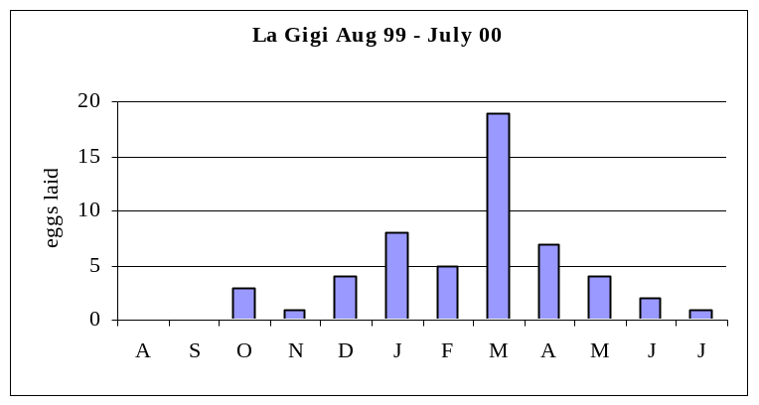

Eggs considered to be replacements following loss of first egg are not included (1 in Jan, 2 in Feb, 1 in March, 3 in April, 1 in May, 1 in June).
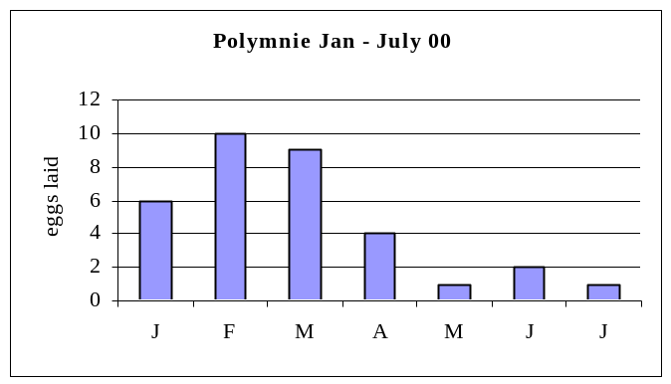

Presumed re-lays are not included (1 each in March, April, May & June).

There was a wave of fledging in March from eggs laid on Polymnie ilot 4 in November.

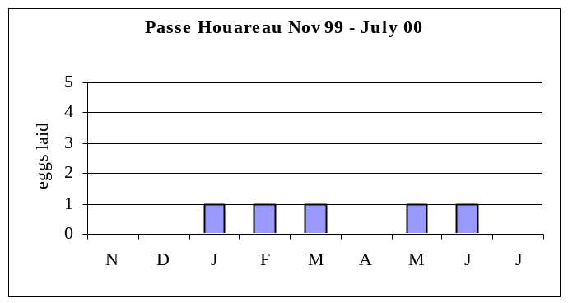

Breeding was seasonal, with the peak of egg-laying January-March (although Polymnie ilot 4 does not fit this pattern – see below). Diamond described aseasonal breeding with slight peaks December-February and April-May, thought to be abnormal by Prys-Jones and Peet who ascribed this to failure of the 1967/8 wet season. Prys-Jones and Peet found egg-laying peaked in January-February during 1975-1977.

Breeding success

La Gigi

Of 60 eggs laid between 25/8/99 and 7/8/00 at 50 marked sites, 9 young fledged, with a further cycle ongoing, a minimum success rate of 15%. Large, fully-feathered young were assumed to have fledged (an assumption made by Prys-Jones and Peet).

Polymnie

Of 44 eggs laid between 31/1/00 and 14/7/00 at 40 marked sites, 5 young fledged with a further 2 cycles ongoing, a minimum success rate of 11.4%.

9 young fledged synchronously in March on Ilot 4 from an unknown number of eggs laid in November.

Passe Houareau

No young fledged from 5 eggs laid between 5/11/99 and 27/7/00 at 5 marked sites.

If only completed cycles and their sites are considered:

 | La Gigi | Polymnie | Passe Houareau | Total
Eggs laid | 59 | 42 | 5 | 106
Young fledged | 9 | 5 | 0 | 14
No. of sites | 48 | 39 | 5 | 92

Overall breeding success was 13.2%.
Productivity 0.15 fledged young per site.

The true figures will be lower than this, since monthly recording will miss eggs laid and lost between visits (this also applies to the earlier studies). Breeding success in 1967/8 was 4.4%, in 1969 44.4% and in 1975-77 45%.

8 cycles are known to have failed at the egg stage, 14 at the small chick stage (younger than 20 days) and another 60 at either the egg or small chick stage, the total of 82 accounting for 90% of failed attempts. For the remainder the stage of failure was not known, usually due to inability to relocate the site.

The crab Geograpsus stormii was seen to take an egg of rubricauda and Robber Crabs Birgus latro are a potential predator on most ilots, although they were never seen. A Ship Rat Rattus rattus was seen on 2 La Gigi ilots, and they must reach other ilots on occasion, especially on spring low-tides at night. Pied Crows are often seen foraging on the ilots and harassing Black-naped Terns in particular. Both tropicbirds rarely leave an egg unattended and are fierce protectors of the site, and the small, unattended chick stage is the most vulnerable. Most surprisingly a Malagasy Coucal Centropus toulou was seen eating a freshly killed rubricauda chick of c2 weeks old at Polymnie. This species is adapted to crawling through dense vegetation, particularly on the ground, and would make an effective predator of small chicks.

P. rubricauda has a normal interval between layings of c12 months, and one of the few birds marked by Prys-Jones & Peet conformed to this pattern. 13 of 17 detected repeat layings at marked sites in the current study occurred within 10 weeks and are assumed to have been replacements for lost eggs (Diamond found the interval for marked birds to be 40-71 days). The remaining 4 instances, following intervals of 3-6 months, probably involved different birds, although without ringing individuals this is speculative. Diamond considered competition for nest-sites to be a factor at Aldabra, and adults are known to evict chicks to take over a site.

Population estimate

Diamond assigned survey ilots to one of 5 categories according to structure and obtained figures for the total numbers of each ilot type in the Lagoon, then extrapolated. Following his method and tabulation:

Density-derived estimate according to ilot type
Ilot type | 3a | 3b | 4 | 5 | Total
No. ilots sampled | 17 |  | 9 | 7 | 33
Occupied sites | 5 |  | 53 | 41 | 99
Density | 0.29 | (3.09) | 5.89 | 5.86
Total ilots in Lagoon | 515 | 175 | 140 | 76 | 906
Total occupied sites | 149 | 541 | 825 | 445 | 1960

No sites were found at La Gigi prior to the inclusion of the samples at Polymnie and Passe Houareau which were not active subsequently, so no adjustment was made to totals for the latter 2 samples.

No ilots of Diamond’s ilot type 3b were in either study. His procedure of assigning a density mean of types 3a and 4, based on physical characters mid-way between types 3a and 4, has been followed.

The population estimate is 1,950 pairs (1,880 in 1967/9). Because of the small sample (3.6% of potentially suitable ilots) this figure is approximate and confidence limits cannot be given.

Future monitoring
Monitoring of La Gigi ilots 13 and 14 and Polymnie ilots 01 and 04 should continue. These ilots contain over 70 sites of rubricauda and only one of Grey Heron. More frequent visits would give a clearer picture of egg-laying and nest-failure.
Ringing of adults and young would establish a long-term study population similar to that of lepturus on Aride Island, inner Seychelles, and enable studies of survival, chick growth, age of first breeding, site and mate fidelity etc., all useful indicators of the condition of local seabird populations and the marine environment. Apart from a handful on Aride, Aldabra’s is the only population in Seychelles and is presumably the largest of the nominate race.

To obtain a more reliable estimate of the population, as many Type 3, 4 and 5 ilots as possible should be searched for occupied sites during January-March, with reference to the regularly monitored ilots for appropriate adjustments to the figures.

Polymnie ilot 04

Diamond’s ilot classification is based on structure rather than vegetation. Although structurally a type 5 ilot, Polymnie 04 is strikingly different from all others studied in being covered in a dense and uniform mat of a single plant species, the perennial, rush-like Plumbago aphylla, appropriately Herb Payanke (tropicbird) in Creole. This provides an easily-penetrated burrowing medium over one metre tall in which tropicbirds can fashion their own chambers rather than having to locate and defend sites among a limited number of suitable formations of rock and scrub vegetation. The all-enveloping roof of matted stems provides reliable shade, thought to be a crucial factor in breeding success for rubricauda by Prys-Jones & Peet.

Breeding density and productivity on the ilot would appear to be significantly higher as a result, synchronisation
is highly developed, and a portion of the sub-colony shows a different seasonality: 9 young fledged in March from eggs laid in November, in advance of the general laying peak with which the remainder of the 04 group conformed. Only 5 young fledged from 37 eggs laid at Polymnie between January and May, 4 of them in May-June on ilot 04.

It is generally true that older, more experienced adults show greater breeding success, that young tropicbirds tend to return to the natal area to breed, that there is strong site and mate fidelity which may be disrupted by breeding failure, and that synchronously breeding colonial seabirds show greater productivity with greater synchronisation. It would be interesting to investigate the divergence of this sub-colony, the degree of relatedness of its members, and the level and nature of interchange with other ilots.

Similar ilots in the Lagoon will be easily identifiable, and could be important sources of recruitment for the atoll’s rubricauda population (assuming they are free of rats).

1.2.1.2 White-tailed Tropicbird Phaethon lepturus

Breeding seasonality

Month of laying was estimated for all eggs found. Cycles which had started before the first visit are not included.

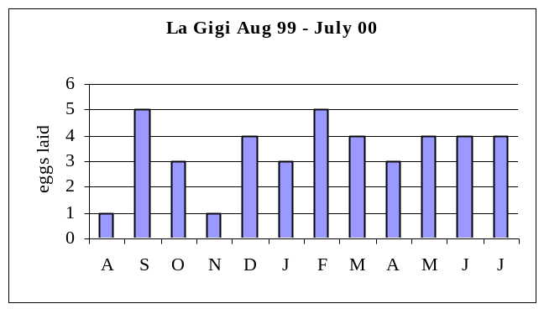

Presumed re-lays (1 in March, 1 in May) are not included.

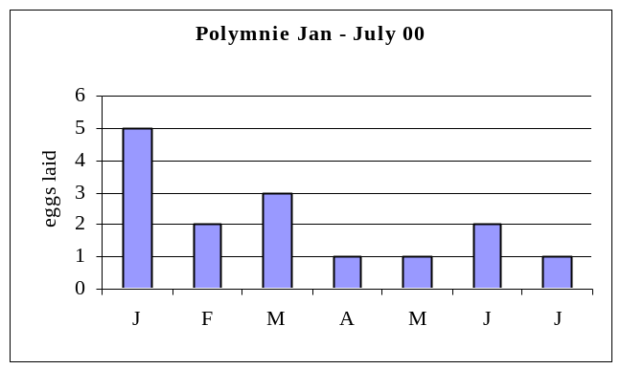

A presumed re-lay in March is not included.

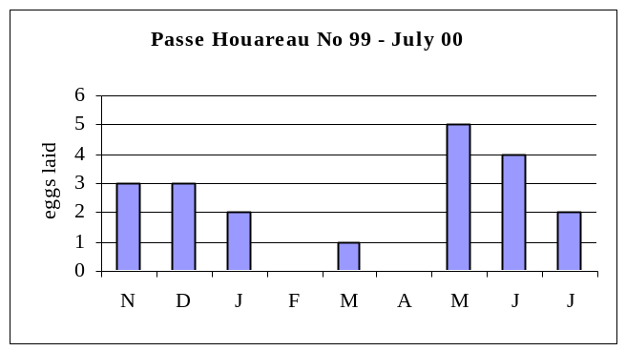

Breeding was aseasonal, with no clear peak in egg-laying over all 3 sites. Both Diamond’s and Prys-Jones & Peet’s studies found the same.

Breeding success

La Gigi

Of 40 eggs laid at 34 marked sites between 25/8/99 and 7/8/00, 10 young fledged and 10 cycles are ongoing, a minimum success rate of 25%.

Polymnie

Of 14 eggs laid at 13 sites between 31/1/00 and 14/7/00, 5 young fledged and 4 cycles are ongoing, a minimum success rate of 35.7%.

Passe Houareau

Of 23 eggs laid at 21 sites between 5/11/99 and 27/7/00, 7 young fledged and 3 cycles are ongoing, a minimum success rate of 30.4%.

If only completed cycles and their sites are considered:

 | La Gigi | Polymnie | Passe Houareau | Total
Eggs laid | 30 | 10 | 20 | 60
Young fledged | 10 | 5 | 7 | 22
No. of sites | 29 | 9 | 20 | 58

Overall breeding success was 36.7%.
Productivity 0.38 fledged young per site.

The true figures will be lower than this, since monthly recording will miss eggs laid and lost between visits.
Breeding success was 50% in 1967/8, 46.1% in 1969 and 46% in 1975/7.
6 cycles are known to have failed at the egg stage, 4 at the small chick stage (younger than 20 days) and 28 at the egg or small chick stage, accounting for all failures. Potential predators are the same as for rubricauda.

Interval between egg-laying for this species is typically 9-10 months, sometimes less if the first cycle was unsuccessful. Relaying at 10 marked sites seemed to follow this pattern, with 3 intervals of 9-10 months and another 7, following unsuccessful earlier cycles, of somewhat less. This suggests that only one pair was involved at each site. On a further 3 occasions eggs were laid after less than 11 weeks and were probably replacements.

Fierce competition for best sites, even when suitable sites are plentiful, is a feature of this species. One particularly bloody duel was seen at Polymnie.

Population estimate

Density-derived population estimate according to ilot type
Ilot type | 3a | 3b | 4 | 5 | Total
No. ilots sampled | 17 |  | 9 | 7 | 33
Occupied sites | 31 |  | 31 | 13 | 75
Density | 1.82 | (2.63) | 3.44 | 1.86
Total ilots in Lagoon | 515 | 175 | 140 | 76 | 906
Total occupied sites | 937 | 460 | 482 | 141 | 2020

2 of 25 occupied sites at La Gigi were found prior to inclusion of the samples at Passe Houareau and Polymnie which were not active subsequently. An adjustment of 8% was applied, adding 1 site to the total at Polymnie and 2 at Passe Houareau.

No marked sites were thought to have been used by more than one pair.

The population estimate is 2,000 pairs (2,530 in 1967/9). Because of the small sample (3.6% of potentially suitable ilots) this figure is approximate and confidence limits cannot be given.

Future monitoring

Monitoring of La Gigi ilots 01 and 14, Polymnie 01 and Passe Houareau 05 and 07 should continue. Along with the lepturus sites on the ilots monitored for rubricauda, this will involve over 30 sites. A further ilot or ilots should be located, free of Grey Herons, to increase this sample size. Visits every 2 weeks would give a clearer picture of egg-laying and nest-failure.

Aseasonal breeding makes census more difficult than for rubricauda. A count of active sites during a large-scale rubricauda census, as recommended above, ideally with a second count of the same ilots in September-October, combined with information from the regularly monitored ilots, would improve the accuracy of the current figure and enable confidence limits to be used..

1.2.1.3 Greater and Lesser Frigatebird Fregata minor and F. ariel

Census

Census and monitoring are research priorities (MP 4.2.4) but have not been carried out since Reville’s work in 1976/7.

Dr. Alan Burger of BirdLife Seychelles counted active frigate nests at the 3 colonies (Gionnet, Camp Fregat and Middle Camp) from a one man kayak between 12 and 20/3/00 (large chick stage), with logistical support from atoll staff, who subsequently surveyed southern and southeastern shorelines to confirm the absence of further colonies.

Although timing and methods differed from those of the previous census (Reville, 1976/7), it appears there has been no appreciable change in distribution or numbers. This would indicate populations have remained stable at c 4,000 pairs of minor and c 6,000 pairs of ariel, although since the current counts were largely of young, the 2 species were not distinguished. In view of the cessation of heavy human predation in the late 1960’s, it is surprising numbers have not increased.

Distribution of nesting Frigates, based on the March census, is shown in Appendix 12.
Reference: ‘A census of Red-footed Boobies, Greater and Lesser Frigatebirds on Aldabra Atoll in March 2000’ A. E. Burger. Report to BirdLife Seychelles , 2nd Dutch Trust Fund and SIF.

Future monitoring

To obtain the most comprehensive count of breeding pairs this should be done during incubation, at a point when most pairs have laid and before many have failed. This is also the period when disturbance can result in nest-robbing with consequent egg loss. Counting at the large chick stage will have less impact but will not account for the significant number of nest failures. At the egg stage it is also important not to flush incubating birds, which need to be identified to species and counted, so approach should not be closer than 30m and oars rather than engine used wherever possible.

- Representative sections of each of the 3 colonies, chosen for density of nesting frigates and vulnerability to disturbance, should be marked and counted during the peak of early incubation. The colonies at Gionnet (ariel) and at Camp Fregat (minor) can be checked regularly to assess progress of the breeding cycle, but peak incubation should be July-September for ariel and August-October for minor. Identify and count incubating birds.

- Repeated counts of the same study plots at intervals of 4-6 weeks. Incubation is c55 days and fledging c150 days. Counts of incubating birds and visible chicks would enable refinement of Count 1 and provide information on patterns of breeding success and failure, but they are less important than counts 1 and 3.

- Complete count of nests in all 3 colonies mid-February to March at the large chick stage, in sections identifiable by permanent features (mark if necessary). The sections used in Count 1 must be repeated exactly. This count can be combined with a count of Red-footed Booby nests.

Comparison of number of incubating birds in the study plots (count 1) with number of chicks in the same plots (obtained from count 3) will give a figure for breeding success which can then be applied to the total number of chicks (count 3) to estimate the total number of pairs which attempted to breed. Relative breeding success between colonies should indicate any significant impact of tourist visits at Gionnet.

Census should be made at intervals of not more than 3 years, and a measure of relative productivity annually.

Frigatebird kleptoparasitism

In 1998/9 a record was made of 50 Frigatebird attacks on incoming seabirds at the Station (see RO Annual Report 1998/9). In 1999/00 a further 60 attacks were recorded (Appendix 5).

Using the 2 year total of 110 observed attacks, 96 of these (87%) were made by adult female minor, 92 of them on Red-footed Boobies. 47 of these resulted in regurgitations, and the fish was retrieved on 37 occasions, a success rate for Great Frigatebird : Red-footed Booby of 40%. Up to 6 females occasionally pursued a single Booby. Other species attacked by adult female minor were Crested Tern (3 occasions) and Dimorphic Egret (once).

Adult male minor made only 4 attacks, three on Red-footed Boobies (one of them in conjunction with a female minor) and once on Crested Tern.

Immature minor twice joined in attacks initiated by adult female minor, and on one occasion carried out a solo, unsuccessful attack on a Red-footed Booby.

Adult male ariel were involved in 10 attacks on Brown Noddy and one each on Sooty Tern and Fairy Tern.

Adult female ariel were involved in only 3 attacks, all on Brown Noddy, 2 of them in conjunction with adult male ariel.

An immature ariel joined an adult male ariel in one attack on a Brown Noddy, the adult retrieving the fish.

Outside this study, 3 adult and 2 immature male (by size) minor were watched above a small, drying-out pool near Cinq Cases on 28/4/99, where c70 Dimorphic Egrets and 6 Grey Herons were tightly packed, feeding on a glut of fingerling fish up to 4" long. The Frigates took turns to dive selectively at the Grey Herons, clearly trying to make them disgorge, although this was not observed.
Visitor disturbance to Frigatebirds

Monitoring of the impact of tourist visits on the Frigate colony at Gionnet, the only one of the 3 colonies where guided visits are permitted (MP 2.3.2), continued as described in the previous RO Report and in ‘Frigatebird disturbance at Gionnet’ (Johnson & Threadgold 1999, report to SIF), which itself followed earlier work by Augeri & Pierce in 1995.

Counts are made of:

- All birds in the air over the colony, from c 200 metres.
- All birds taking flight during the visit.
- All birds remaining on branches, excluding unfledged young.
- All birds in the air after the visit, from c 200 metres.

This is carried out separately at Colony A (Gros Ilot Gionnet) and Colony B (Passe Gionnet). Count 3 is the most difficult at periods when Frigate young are large and not easy to distinguish from juveniles and immatures capable of flight. Wing-length, posture and behaviour, remains of a nest and location (most nests are clumped) are usually helpful.

In the table below, counts 2 and 3 are combined to give ‘birds at rest’:

Percentage of Frigatebirds taking flight during visits

Date | Colony A Birds at rest | Colony A % disturbed | Colony B Birds at rest | Colony B % disturbed | No. of Boats
20/1/99 | 92 | 31.5 | 118 | 22.9 | 2
16/2/99 | 86 | 19.8 | 107 | 7.5 | 1
1/3/99 | 194 | 38.7 | 125 | 13.6 | 1
13/3/99 | 146 | 31.5 | 122 | 15.6 | 3
10/8/99 | 445 | 28.8 | 302 | 5.3 | 1
2/9/99 | 379 | 30.6 | 295 | 16.3 | 1
15/9/99 | 212 | 32.5 | 188 | 4.3 | 1
26/10/99 | 530 | 30.2 | 427 | 1.6 | 1
1/11/99 | 440 | 11.4 | 142 | 1.4 | 3
4/11/99 | 656 | 10.1 | 479 | 6.1 | 1
17/11/99 | 610 | 23.0 | 247 | 15.4 | 2
28/11/99 | 191 | 20.9 | 158 | 12.0 | 3
12/3/00 | 153 | 23.5 | 138 | 13.0 | 2
16/3/00 | 203 | 29.1 | 181 | 3.9 | 2
5/4/00 | 222 | 46.4 | 181 | 6.1 | 2
14/4/00 | 112 | 22.3 | 121 | 4.1 | 2

Mean disturbance of roosting Frigates at Colony A was 26.9%, and at Colony B 9.3%. This confirms Johnson & Threadgold’s finding that disturbance levels at Colony A are much higher, probably due to the sound-channeling or amplification effects of the topography : at Colony A an offset ilot causes boats to pass closer to the birds (c7m) and amplifies engine sound. The exceptionally high abandonment rate here on 5/4/00 was due to a combination of noisy tourists and strong currents which necessitated some engine revving. When possible, paddles were used by the zodiacs of ‘Indian Ocean Explorer’. There is no apparent relationship between month of visit or number of boats and level of disturbance.

Engine mufflers, recommended in the previous report, were not obtained.

Recommendations:

1. Use of engine muffler when use of paddles is not possible. No revving of engines or other unnecessary noise.

2. Ideally visits should be restricted to Colony B, and approach within 10 metres should not be permitted. When Frigates are nest-building or incubating, or have very small young (June-December), disturbance is potentially more serious, since temporarily abandonded nests may be robbed by other males, and eggs or young lost. After this phase, when young are large and often left alone, the colony is less vulnerable.

As long as tourists visit Aldabra, it is not reasonable to close the colony to visits. Very few instances of nest-stealing were observed, and no instances of egg or chick loss. 137 large young were counted at Colony A and 146 at Colony B in March, an apparently healthy situation, but it should be possible to compare breeding success with that of an ‘undisturbed’ colony (see Future Monitoring above).

3. Continuation of disturbance counts.

Pattern of Frigatebird attendance at Gionnet colony

Combining counts 1, 2 and 3 above:

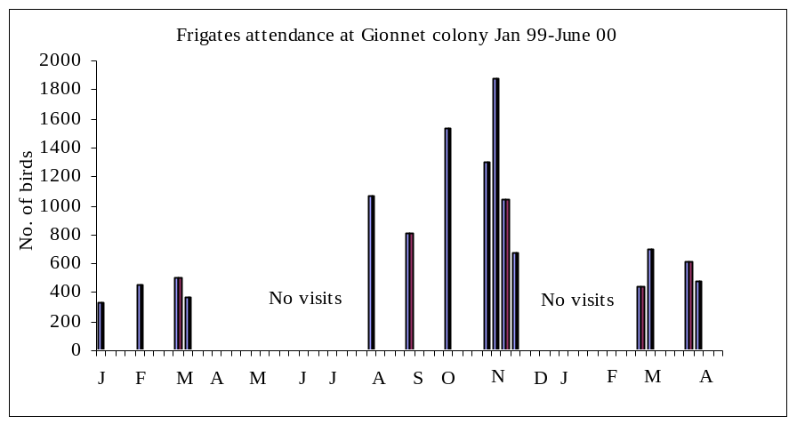

The great majority of Frigates breeding at Gionnet are ariel.

1.2.1.4. Red-footed Booby Sula sula

No census or monitoring has been carried out since Diamond’s in 1967/9.

Census

Dr. Alan Burger counted incubating birds and fledglings (there are two phases of laying) along most of the northern and eastern Lagoon shoreline from a one-man kayak between 12 and 20/3/00, with logistical support from atoll staff who completed surveying the remainder of the Lagoon by 9/5/00.

The Booby population during the NW monsoon has apparently increased by at least 50% since 1967/8, when Diamond estimated 6-7,000 pairs, and has spread along the northern Lagoon shoreline. Three-quarters of them nest apart from frigates. A tentative estimate of the total population would therefore be 9,000 to 11,00 pairs during 1999/2000, putting it close to that of Cosmoledo, which at 10-12,000 pairs (Rocamora & Skerrett, in press) is the largest in the Western Indian Ocean. This increase is presumably due to the cessation of significant human predation in the late 1960’s.

Full details are given in Alan Burger’s report (see Frigatebird census above).

Counts of incoming birds by age group

Boobies returning to the atoll in the evening over a period of 1 hour (c1800-1900) were counted opportunistically on 20 occasions according to 3 age groups :

- Adult. Over 99% of adults on Aldabra are of the distinctive white morph, with a very small number of the white-tailed brown morph. This was found to be so by Diamond in the 1960’s and is still the case today. Age 4 years plus.
- Immatures. A variably patchy, brown and white plumage, 1 to 4 years old.
3. Juveniles First post-fledging plumage, a uniform dark brown. Less than 1 year old (Diamond 74).

Sample size for each count varied from 17 to 159.

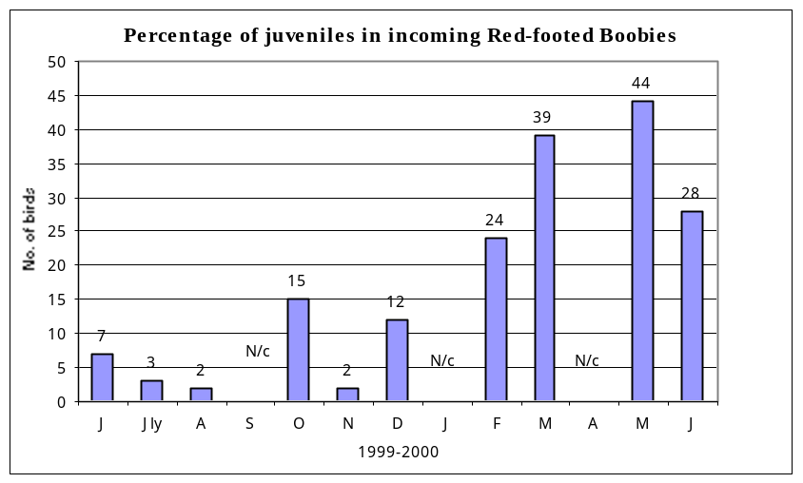

Juveniles are known to travel in groups, although usually with at least one adult when going to sea . Groups of c60 juveniles were seen diving among tuna off the north coast on 5/11/00 and resting on the Lagoon on 17/3/00. It was also noticeable that adults appeared to stay out later, numbers increasing at dusk and into darkness. Nonetheless, repeated counts provide a simple and quite pleasant method of obtaining a rough indication of breeding seasonality and of relative productivity between years.

Future monitoring

1. Count of nests during incubation of each breeding phase, once in the late SE monsoon (September-October) and once in the NW monsoon (February-March). Periodic visits to parts of the colony prior to theses periods will be a guide to timing of the counts, and the February-March count can be combined with a census of frigatebirds (see 1.2.1.3 ). A complete count of the whole of Malabar and the eastern Lagoon shore by small boat, with planning of tides and logistical support, could be achieved in less than 2 weeks. Counts should be made and recorded according to identifiable sections of shoreline.

2. A count of representative sections should be made when most young are nearing fledging, to obtain a measure of breeding success. Incubation and fledging periods for this species are 45 and c110 days.

3. Counts of juveniles as 1.2.5.2 once weekly would provide an approximate index of breeding seasonality and relative productivity between seasons.

Census should be made at intervals of not more than 3 years, and a measure of relative productivity annually.

Booby Taxonomy Study

Tammy Steeves, PhD student at the Department of Biology, Queen's University, Kingston Ontario, made a request for Booby blood and feather samples to assist a global taxonomic study, supervisor Dr. Vicki Friesen, which was approved by the Scientific Committee.

30 chicks of 6-12 weeks old were blood-sampled and each had 2 growing secondary covert feathers removed and stored using equipment provided by Tammy Steeves. The work was carried out by Rangers, Research Officer and Volunteer on the north coast of the Lagoon east of the Frigate colony at Camp Fregate on 16/5/00 and 30/5/00. The samples were posted off with appropriate DoE export consent.

The possibility of visiting Cosmoledo to sample Masked and Brown Boobies now seems remote, but the remaining sampling equipment could be used if the opportunity arises.

1.2.1.5 Audubon’s Shearwater Puffinus l’herminieri

Weekly counts

Visits to Lagoon ilot breeding sites by this species are made at dusk or after dark. Counts were made once weekly from the Warden’s house of birds entering the Lagoon through Passe Femme in the last 20 minutes of visibility.

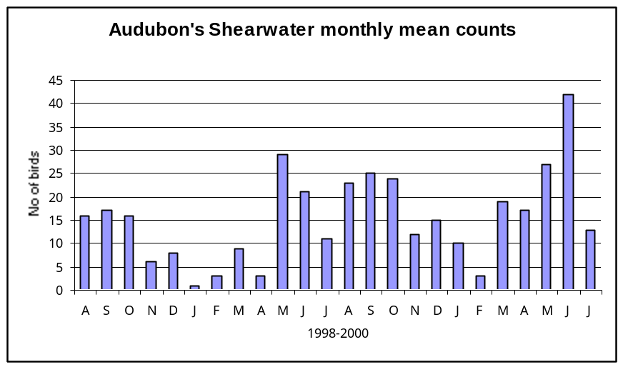

Breeding cycle

Incubation and fledging periods for this species on Galapagos are c 49 and c75 days, with an interval of approximately 9 months between egg-layings (less if the cycle was unsuccessful). Breeding is aseasonal, with small breeding peaks enhanced by food availability. It is assumed this is the case in Seychelles, although ringing has not been carried out and the fact that Galapagos birds are diurnal shows that breeding behaviour can vary.

The histogram does show a seasonal pattern of attendance at the breeding stations. November to April was the period in both 1998/9 and 1999/00 with lowest attendance of adult birds, and this may have been the main incubation period when individuals sit in shifts of several days. During monthly surveys of Lagoon ilots August 99 to July 00 eggs were found in October 99 (1), January 00 (4), March 00 (3), April 00 (2), May 00 (2), July 00 (1). Adult attendance will increase markedly when chicks have hatched.

Potential predators on the ilots are listed under Red-tailed Tropicbird, but Ship Rat is the biggest threat. One was seen on La Gigi ilot 06, where several predated Audubon’s eggs were found, and on La Gigi 18, which is well offshore.

Population estimate and future monitoring

Regrettably, logistical and other constraints prevented a methodical census in 1999/2000 (MP 4.2.4). A very rough extrapolation from the small number of active sites located (15), based on Diamond’s ilots counts (see 1.2.1.1) gives a figure of c250 pairs, and the weekly counts, which were made at just one of the smaller channels into the Lagoon, do suggest this is closer than the 50-100 pairs estimated for the IBA. The 15 sites discovered will in fact represent only a proportion of those actually on the study ilots, since all searches were made in daylight. One census method would be to mark all potential sites (usually a complex within a limestone outcrop) on La Gigi ilots 06, 07 and 08 with reflective tape. A visit would then be made after dark with torch and cassette player and a tape of Audubon’s calls played to determine percentage response of visible birds; the tape would then be played at the entrance to likely sites where the contents cannot be seen (the great majority) and response rate from ‘hidden’ birds assumed to match that for visible ones.

Sites would be numbered and further visits made after 3 and 6 months to locate new breeders. A single visit should be made in January-April when most adults should be incubating to as many type 4 and 5 ilots as possible and the results adjusted using the information from La Gigi. An extrapolation would then be made using the total number of ilots of these types (see tropicbirds). It is not possible to view or touch the contents of most suitable cavities on Aldabra, which are in awkwardly shaped and abrasive natural holes in the coral limestone with shallow earthen floor, rather than in burrows excavated by the birds themselves. If the sample of visible birds is too small to derive a reliable response rate, the figure obtained on Aride Island in 1997 could be applied.

A potential site count followed by application of a percentage occupancy figure derived from the La Gigi ilots would not work as individual Aldabran sites within the coral limestone cannot usually be distinguished.

Visiting ilots after dark, where the terrain is hostile and boat pick-ups are difficult, would involve some risk of injury.

Rat trapping should be carried out on the La Gigi ilots, where traps can be checked next day.

The weekly evening counts are a simple way to follow pattern of attendance and should pick up any significant changes. Further counts could be carried out at Passe Houareau during camp visits.

Unpublished DNA analysis shows that Aldabra birds do not constitute a distinct race of Puffinus l’herminieri (Adrian Skerrett, pers. comm.).

1.2.1.6 Black-naped Tern Sterna sumatrana

Breeding seasonality

Of 34 Lagoon ilots surveyed at La Gigi, Polymnie and Passe Houareau, Black-naped Terns nested only on 8 of the La Gigi ilots and one at Polymnie. 15 breeding attempts were recorded, with egg-laying in February-March on 10 occasions and August-September on 4 occasions, plus a single laying in October. Diamond found that 75% laid in January-February, the remainder in March-June.

Breeding success

Only 2 pairs were definitely successful in fledging 2 young each, but with a fledging period of 24-28 days it is quite possible fledging occurred sometimes between monthly visits. Where eggs were found on the point of hatching, the 2 young fledged after 28 days.

Most failures appeared to be at the egg stage. Pied Crows were clearly attempting to steal eggs on several occasions, although no actual theft was seen. The adults make it very obvious which ilots have nests. For other potential predators see Red-tailed Tropicbird.

Population estimate

15 pairs bred on Type 3, 4 and 5 ilots. During March Alan Burger counted 14 pairs between Passe Dubois and Ile aux Cedres, as he travelled along the Lagoon’s northern shore. Taking into account the August-September breeding segment of the population it is unlikely that more than 50 pairs bred during the year. Diamond estimated no more than 70 pairs in 1967/9 and it is probable there has been no significant change.

Future monitoring

It should be possible to travel the Lagoon perimeter in February-March and count all active sites as advertised by the territorial behaviour of adults (the northern portion would coincide with Frigate and Booby counts). Active ilots should be mapped. The count should be repeated in August-September.

Ilots 02, 05, 09, 11, 15, 17 and 19 at La Gigi should be monitored for breeding success : by observation from the shore and during boat trips in February-March and August-September it will be evident when nesting is taking place. A landing will enable a check of nest location and number of eggs, and weekly observation through binoculars from boat or shore will reveal young which survive to be large enough to see. They are very mobile shortly after hatching and hide at the adults’ warning call, so landing to search will usually be unsuccessful and cause unnecessary disturbance. This approach should record all young to fledge and give a better idea of breeding success.

1.2.1.7 Caspian Tern Sterna caspia

The small Aldabra population is isolated and unusual (possibly unique) in using an oceanic breeding site. Birds are easily disturbed and monitoring must be carried out with care (OM 7.3).

Sightings of Caspian Terns are recorded in the card index. Beginning in March, monthly visits are made on spring tides to the known breeding stations – Iles Moustiques, Esprit, Sylvestre and Champignon des Os. Presence of pairs and territorial behaviour is noted and careful landings are made to carry out quick searches for nests. Landings are not made at the small chick stage since disturbance would be too great and the chicks can hide very easily. When they are fully-feathered they are generally easy enough to see from the boat, and after fledging they remain with at least one parent for up to 8 months. It is therefore possible to monitor productivity.

During 1999 eggs were laid in April at Moustiques and May at Champignon des Os. Two young fledged in July at Moustiques and at least one other fledged, from either a second pair at Moustiques or from Champignon des Os. Maximum count of 8 birds (6 adults) at Moustiques in July.

During 2000 5 pairs are thought to have bred, one at Champignon des Os, 2 at Esprit and 2 (possibly 3) at Moustiques. A nest with 2 small young and one egg was found at Champignon des Os on 2/5/00, nest with 2 eggs at Moustiques on 18/4/00 and nest with 2 eggs at Esprit on the same date. Fledging occurred in June, with 3 at Moustiques, at least one at Esprit, and 2 at Champignon des Os. A pair was briefly territorial at La Gigi in June. This is a former breeding site.

Maximum count in 2000 was 13 at Esprit and Moustiques on 13/6, including one unfledged young.

A bird, possibly 2nd year, forced down by a Frigate on 26/10/99, was ringed 677818 and yellow plastic 11.

      - Greater Crested Tern Sterna bergii

No systematic study. There are two seasonally breeding populations on specific Lagoon ilots. Eggs were seen at Iles Chaland on 6/8/99, with a minimum 9 nests with eggs and young there on 1/9/99, colony deserted by 1/10/99. The maximum count of 32 adults was made at Iles Chaland on 1/9/99.

Future monitoring

Visit all known sites in December-January and again in July-August and count breeding adults with binoculars from a boat. Close observation causes desertion, so landing to count eggs or chicks (until these are large and can be seen from a distance) should not be attempted.

Known breeding sites:

Northern Mentor, Pti Mentor, Iles Chaland, Table Ronde, Ilot Deder, Grand Mentor, Ilot Marquoix, Champignon des Os and Sesame.

1.2.1.9 Brown Noddy Anous stolidus

No systematic study. Breeds on specific Lagoon ilots, most laying September-March, peak December-January.

Future monitoring

Visit known sites December-January alongside Crested Tern census. It should be possible to land at sites not occupied by the latter and count nests. A count of adults before landing would enable a conversion to be made (adults to nests) for those sites where landing would disturb Crested Terns. Visits to selected sites in September-October and February-March would provide an indication of peak laying period, as this can vary.

Known breeding sites:

Coffee Camp, Table Ronde, Pink Rock, Noddy Rock, Ilot Marquoix, Pti Cezanne, Pti Mentor.

